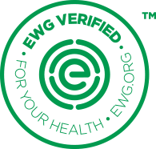

EWG’S SAFETY SUBSTANTIATION NOTICE – BABY DIAPERS

Company understands that in determining whether Company’s product(s) meet the EWG VERIFIED™ criteria, EWG may request the following from Company:

- Laboratory test results that showing that the Company’s product(s) meet relevant contamination and emission restrictions as outlined in EWG’s Licensing Criteria by providing laboratory test results that the product(s) or the “restricted” ingredient present in the product(s) meets the relevant contamination and emmsion standards set by EWG.

Any safety substantiation documentation Company provides to EWG pursuant to a non-disclosure agreement to establish Company meets EWG’s restriction requirements will be shared solely for proof of compliance with EWG VERIFIED™ criteria. EWG has the right to perform random product testing, including through qualified third-party testing services, to ensure that product(s) meet the provisions outlined in EWG’s Licensing Criteria.

